**Exercise 1: Setting Up Junit**

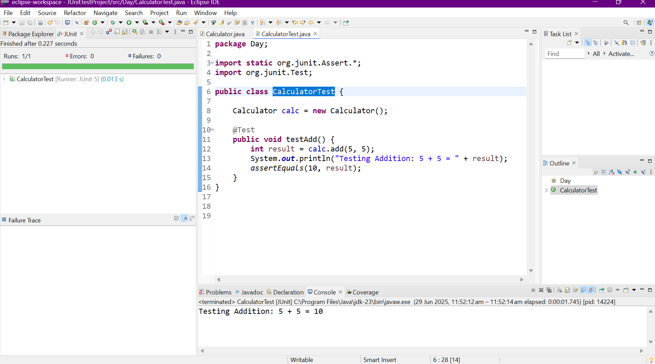

**Exercise 3: Assertions in Junit**

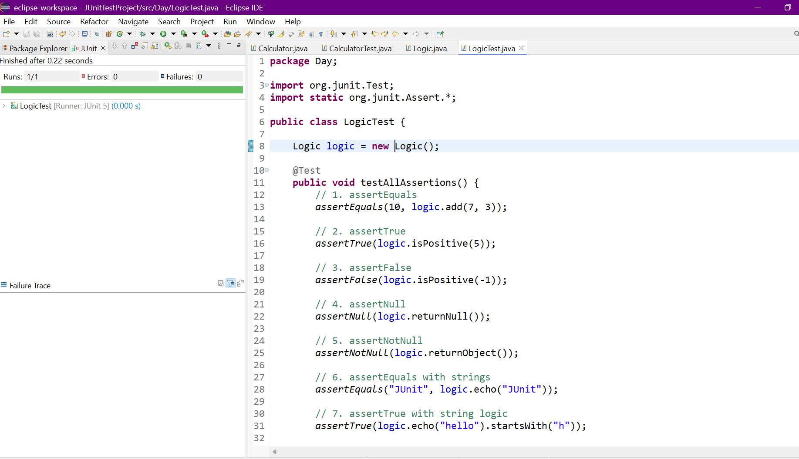

**Exercise 4: Arrange-Act-Assert (AAA) Pattern, Test Fixtures, Setup and Teardown Methods in Junit**

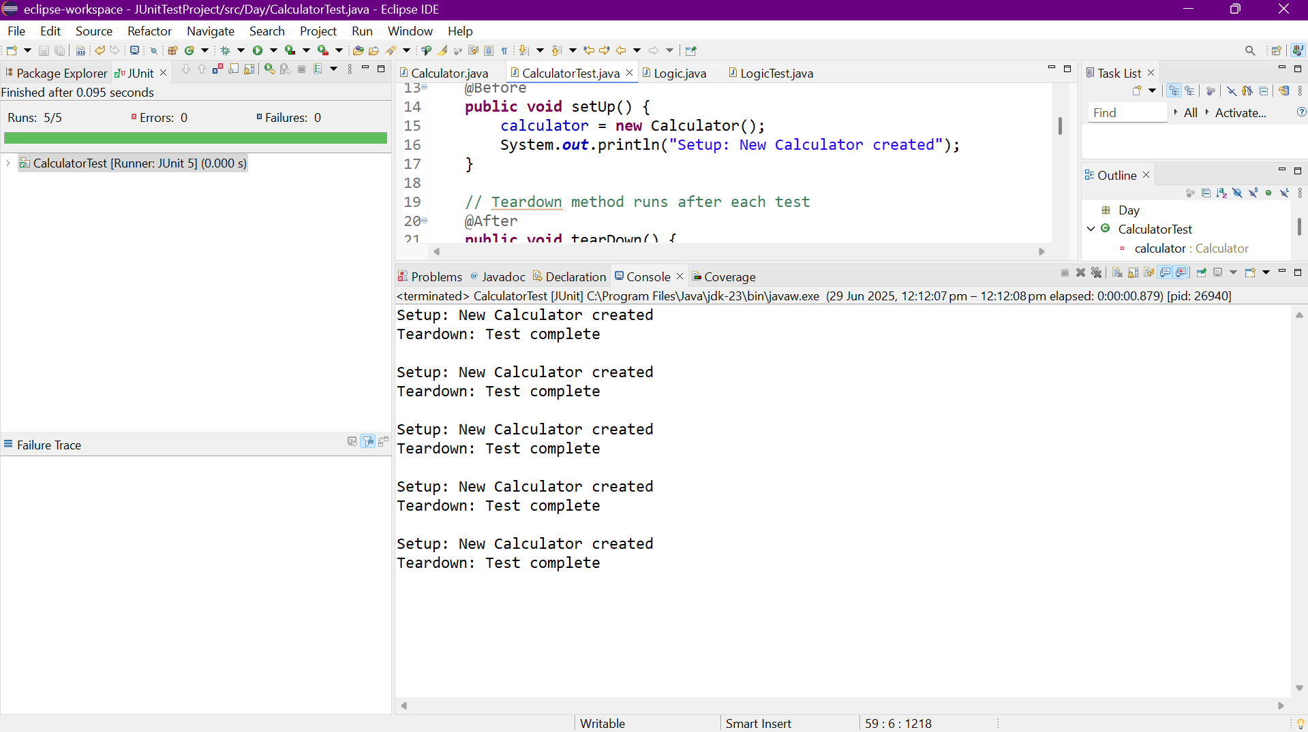

**Exercise 1:** Mocking and Stubbing

OUTPUT:

✔ testExternalApi() [MyServiceTest]

Tests run: 1, Failures: 0

**Exercise 2: Verifying Interactions**

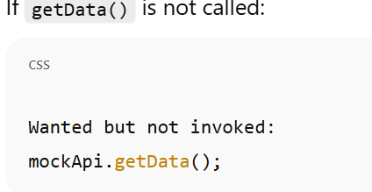

Logging using SLF4J:

